St Gregory’s Safeguarding Curriculum Overview 2023-2024
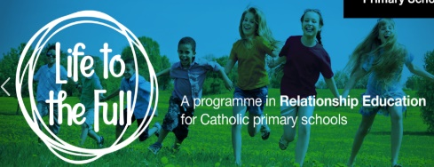

The four C’s of online safety: All online safety units to be taught must explicitly cover the four C’s of online safety: Content, contact, conduct and commerce.

Autumn 1
Online safety- (and share and sign user agreement)
-NSPCC Pants Campaign
-Who can I talk to? St Gregory’s DSL team
-World mental health day
-
-Send parents email with useful websites

Spring 1
-Safer internet day
-E-safety workshop for parents
-Online safety Purple Mash units
- Child net Film Competition introduction
-Send parents email to share useful websites

Autumn 2
-NSPCC- Speak out stay safe (Whole school)
-Anti-bullying week
-Online safety Purple Mash units
-Bonfire safety
-World Kindness Day (13/11)
-Safer internet advice shared with parents ready for Christmas shopping
-Share Child net’s family agreement.

Summer 2

Bike Ability
Online safety Purple Mash units
--NSPCC Pants Campaign
-World friendship day- good friends online
-Email reminding parents of online support over summer.

Summer 1
-Online safety Purple Mash units
-Rail safety
-Sun safety
-Water safety
-National Password Day- 5th May

Spring 2
-Road safety
-Online safety Purple Mash units
-Stranger Danger, being safe in the outdoors, what to do if

***SVSH covered through safeguarding curriculum areas***

Learning outcomes for children

SVSH- Throughout the academic year the children will learn age appropriate strategies to recognise and deal with these risks. This will be covered through the delivery of the RHSE and other identified safeguarding lessons.

NSPCC pants Campaign:
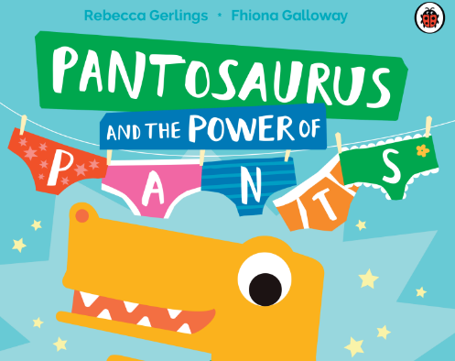
- Talk PANTS helps children understand that their body belongs to them, and they should tell someone they trust if anything makes them feel upset or worried.
- Your underwear covers up your private parts and no one should ask to see or touch them. Sometimes a doctor, nurse or family members might have to. But they should always explain why, and ask you if it's OK first.
- Your body belongs to you. No one should ever make you do things that make you feel embarrassed or uncomfortable. If someone asks to see or tries to touch you underneath your underwear say 'NO' – and tell someone you trust and like to speak to.
- No means no and you always have the right to say ‘no’ – even to a family member or someone you love. You’re in control of your body and the most important thing is how YOU feel. If you want to say ‘No’, it’s your choice.
- There are good and bad secrets. Good secrets can be things like surprise parties or presents for other people. Bad secrets make you feel sad, worried or frightened. You should tell an adult you trust about a bad secret straight away.
- Talk about stuff that makes you worried or upset. If you ever feel sad, anxious or frightened you should talk to an adult you trust. This doesn't have to be a family member. It can also be a teacher or a friend's parent – or even Childline.

Who can I talk to? St Mary’s DSL team
Who are our DSLs?
The children will recognise the St Gregory’s Safeguarding Team and understand their role in keeping them safe
Children will understand that they can talk to a DSL OR any adult in the school setting
The children will know the importance of telling an adult if something is worrying them or making them sad whether it be at home or in school

Online Safety: (Purple mash Units in each year group)
All units to be taught should explicitly cover the four C’s of online safety: Content, contact, conduct and commerce.)
- Don’t post any personal information online – like your address, email address or mobile number.
- Think carefully before posting pictures or videos of yourself. Once you’ve put a picture of yourself online most people can see it and may be able to download it, it’s not just yours anymore.
- Keep your privacy settings as high as possible
- Never give out your passwords
- Cyber bullying Helping Children Deal with Bullying & Cyberbullying | NSPCC
- Don’t befriend people you don’t know
- Don’t meet up with people you’ve met online. Speak to your parent or carer about people suggesting you do
- Remember that not everyone online is who they say they are
- Think carefully about what you say before you post something online
- Respect other people’s views, even if you don’t agree with someone else’s views doesn’t mean you need to be rude
- If you see something online that makes you feel uncomfortable, unsafe or worried: leave the website, turn off your computer if you want to and tell a trusted adult immediately
- risks such as online gambling, inappropriate advertising, phishing, financial scams and gaming.

Parental resources online safety:
Internet matters - Information, Advice and Support to Keep Children Safe Online (internetmatters.org)
Young Minds- Gaming & Mental Health | Parents Guide To Support | YoungMinds
Taming gaming - Family Video Game Database - Guides, Ratings and Suggestions - Family Video Game Database (taminggaming.com)
UK Safer internet centre - Parents and Carers - UK Safer Internet Centre

NSPCC Speak out stay safe:
- abuse in all its forms and how to recognise signs of abuse
- that abuse is never their fault and that they have the right to be safe
- where to get help and the sources of help available, including our Childline service.
- With the help of our mascot Buddy, our Speak out Stay safe programme covers topics like bullying and abuse - without using any scary words or adult language.
- Children learn about the different types of abuse in a child-friendly and age appropriate way, so they can get help if or when they need it. We help them identify a trusted adult they can talk to if they're ever worried about themselves or a friend. And they learn about Childline, and how it can support them.

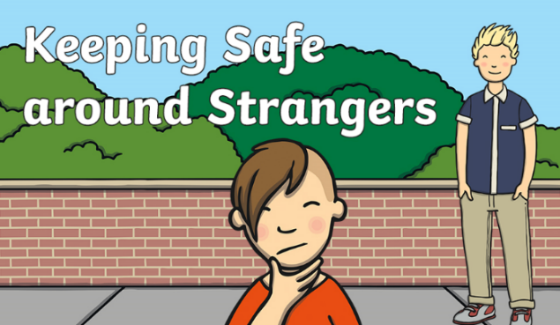
Stranger danger:
Keeping Safe Around Strangers Assembly Pack (twinkl.co.uk)
• Who is a stranger
• Where you might meet a stranger
• Who is a good stranger
• What to do if you meet a stranger.
• How strangers can trick you.
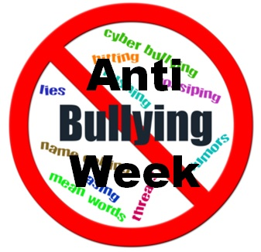
Anti-bullying week:
- Anti-Bullying Week is an annual UK event held in the third week in November which
aims to raise awareness of bullying of children and young people, in schools
and elsewhere, and to highlight ways of preventing and responding to it.
Anti-Bullying Alliance

Parent workshops:
- share resources
- e-safety policies and procedures
- Online safety sessions
- show parents the learning resources you use in the classroom.

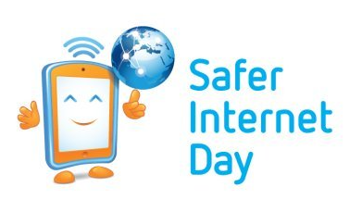
Safer internet day
Home - Safer Internet Day
- How to stay safe on the internet

Rail safety
Primary school resources - Network Rail
- Historically how trains have been powered over the centuries.
- The benefits of railway electrification.
- The power and danger of electricity used on the railway and at home.
- How to be safe around the railway.
- The relationship between decision making and consequences.
- Peer influence and emotional resilience in relation to safety

Road safety:
Education | Road Safety | Sandwell Council
Digital Road Safety | Games Based Learning
- Seat-belts, hold hands, what is traffic, stop- look -listen, safe places to play
- Green Cross code, safer places to cross, be bright be seen
- hazards, Cycle skills
- crossing where there are no "safer places",
- Safer Cycling, seat belts, speed, Arrive Alive (highway code for young road users)
- Accident Procedure (999), making roads safer, safer routes to secondary schools

Sun safety:
Free Resources (sunsafeschools.co.uk)
- Children will learn about safe and unsafe exposure to the sun and how to reduce the risk of sun damage/health damage.

Water safety:
water-safety-lesson-plan.pdf (canalrivertrust.org.uk)
- Children will learn how they can stay safe when near different water sources including lakes and canals.
- Visiting canals, rivers, lakes and reservoirs is a fun and rewarding activity for children and adults alike.
- In order to get the most from canals and rivers, it is vitally important that anyone visiting them follows some simple safety guidelines.

Bike Ability
Sandwell (bikeright.co.uk)
- Sandwell Bike Right! gives the children the opportunity to learn to ride a bike safely.
- Children learn what protective clothing and gear must be worn and why this keeps us safe.
- The children learn how to stay safe when riding a bike out in public especially near roads.

